**(HUNGARIAN METHOD)  
  
Q. You work as a manager for a chip manufacturer, and you currently have 4 people on the road meeting clients. Your salespeople are in Karachi, Lahore, Quetta and Islamabad, and you want them to fly to three other cities: Peshawar, Hyderabad, Rawalpindi and Faisalabad. The table below shows the cost of Train tickets in PKR between the cities: (Prices are in thousands; 1 = 1000 PKR)**

|  |  |  |  |  |
| --- | --- | --- | --- | --- |
|  | **Peshawar** | **Hyderabad** | **Rawalpindi** | **Faislabad** |
| **Karachi** | **20** | **4** | **15** | **13** |
| **Lahore** | **5** | **18** | **3** | **5** |
| **Quetta** | **12** | **11** | **15** | **7** |
| **Islamabad** | **3** | **17** | **2** | **4** |

**So where would you send each of your salespeople in order to minimize fair?**

**IMPLEMENTATION IN PYTHON  
  
PROGRAM:**  
import numpy as np

import itertools

costs = np.array([[20, 4, 15, 13],

[5, 18, 3, 5],

[12, 11, 15, 7],

[3, 17, 2, 4]])

minsums, colixs = [], []

its_size = np.shape(costs)[0]

np.random.seed(0)

rowix = list(range(group_size))

for colix in itertools.permutations(range(its_size)):

_sum = np.sum(costs[rowix,colix])

minsums.append(_sum)

colixs.append(colix)

minsum = np.min(minsums)

mincolix = colixs[np.argmin(minsums)]

print("Total cost:",minsum,"Thousand PKR")

print("Row:",rowix, "Col:", mincolix)  
  
**OUTPUT:**  
Total cost: 17 Thousand PKR

Row: [0, 1, 2, 3] Col: (1, 2, 3, 0)  
  
**ANSWER:**   
Salesperson 1 will ride from Karachi to Hyderabad = 4000  
Salesperson 2 will ride from Lahore to Rawalpindi = 3000  
Salesperson 3 will ride from Quetta to Faisalabad = 7000  
Salesperson 4 will ride from Islamabad to Peshawar = 3000  
  
Total Minimum Optimal cost is = 17000 PKR

**Python Code Screenshot:**   
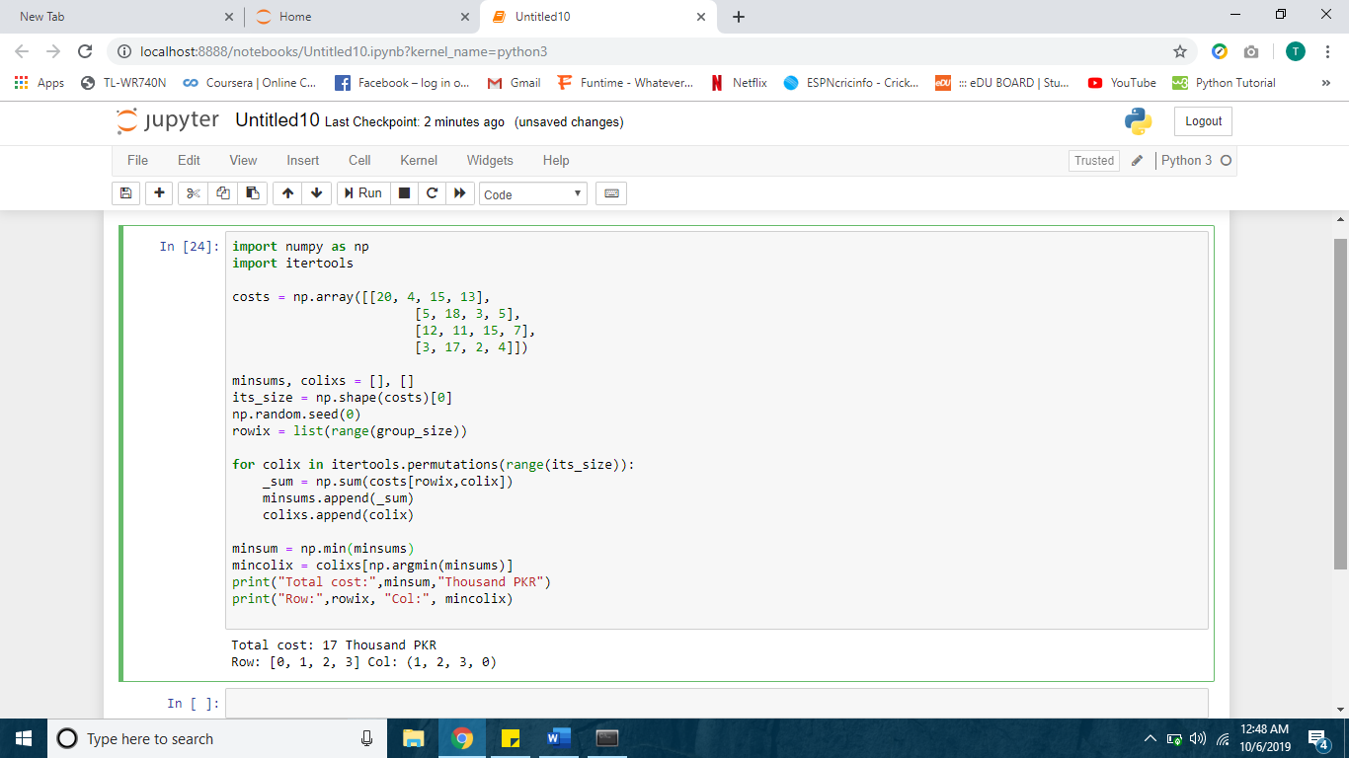

**Its Solution Screenshots:**   
